 | School of Engineering & Technology
 | Department: SOET | Session: 24-25 Even
 | Program: B. Tech CSE | Semester: IV
 | Course Code: ENCS254 | Name: Vandana Sharma  Roll No: 2401010285
 | Course Name: Database Management Systems Lab | Faculty: Ms. Mansi Kajal

Lab Sheet: 1
Objective:
- To design ER diagrams and convert entities and relationships into relational tables using proper schema notation.
Instructions:
- Open your preferred Database Management System (DBMS) tool.
- Create a new database named DBMS_YourName.
- Draw ER diagrams for the given scenarios.
- Convert entities and relationships into relational schemas.
- Create tables using the derived schemas.

Relational Schema

PART A – COLLEGE DATABASE
STUDENT ( USN, SName, Address, Phone, Gender )
SEMSEC ( SSID, Sem, Sec )
CLASS ( USN, SSID )
SUBJECT ( Subcode, Title, Sem, Credits )
IAMARKS ( USN, Subcode, SSID, Test1, Test2, Test3, FinalIA )

PART B – COMPANY DATABASE

EMPLOYEE ( SSN, Name, Address, Sex, Salary, Superssn, Dno )
DEPARTMENT ( Dno, Dname, Mgrssn, Mgrstartdate )
DLOCATION ( Dno, Dloc )
PROJECT ( PNo, PName, PLocation, DNo )
WORKS_ON ( SSN, PNo, Hours )

PART C – CUSTOMER SALE SCHEMA

  - Database Schema for a customer-sale scenario
  - Customer(Cust id : integer, cust_name: string)
  - Item(item_id: integer, item_name:string, price: integer) Sale(bill_no:integer,bill_data:date,cust_id: integer, item_id: integer, qty_sold: integer)

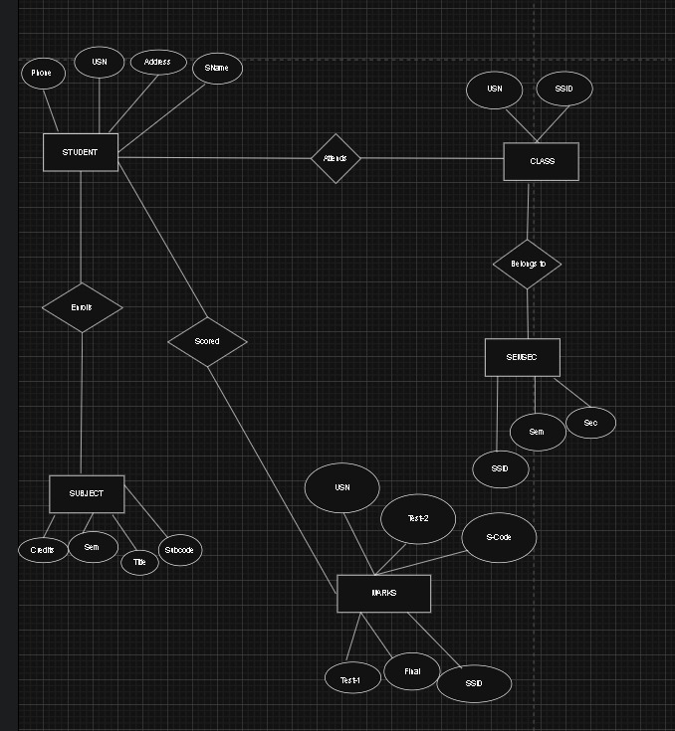

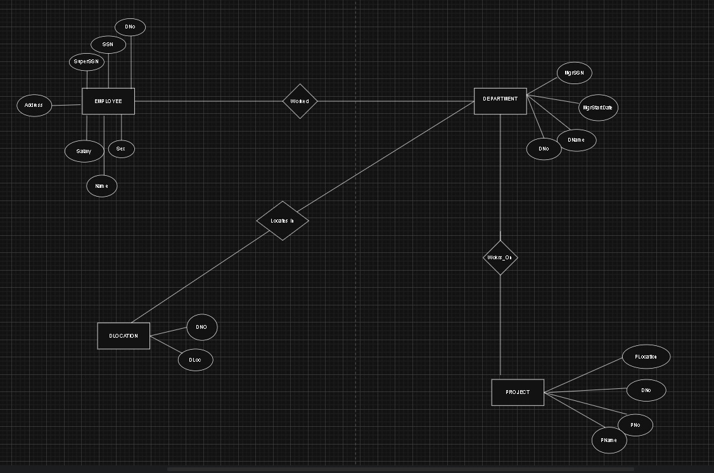

DDL Questions (Data Definition Language):

- Write SQL statements to create all the above relations with appropriate PRIMARY KEY and FOREIGN KEY constraints.
- Add a new column Email to the STUDENT relation.
- Apply NOT NULL constraints to Salary and Price attributes.
- Rename attribute SName to StudentName in STUDENT relation.
- Drop the DLOCATION relation.

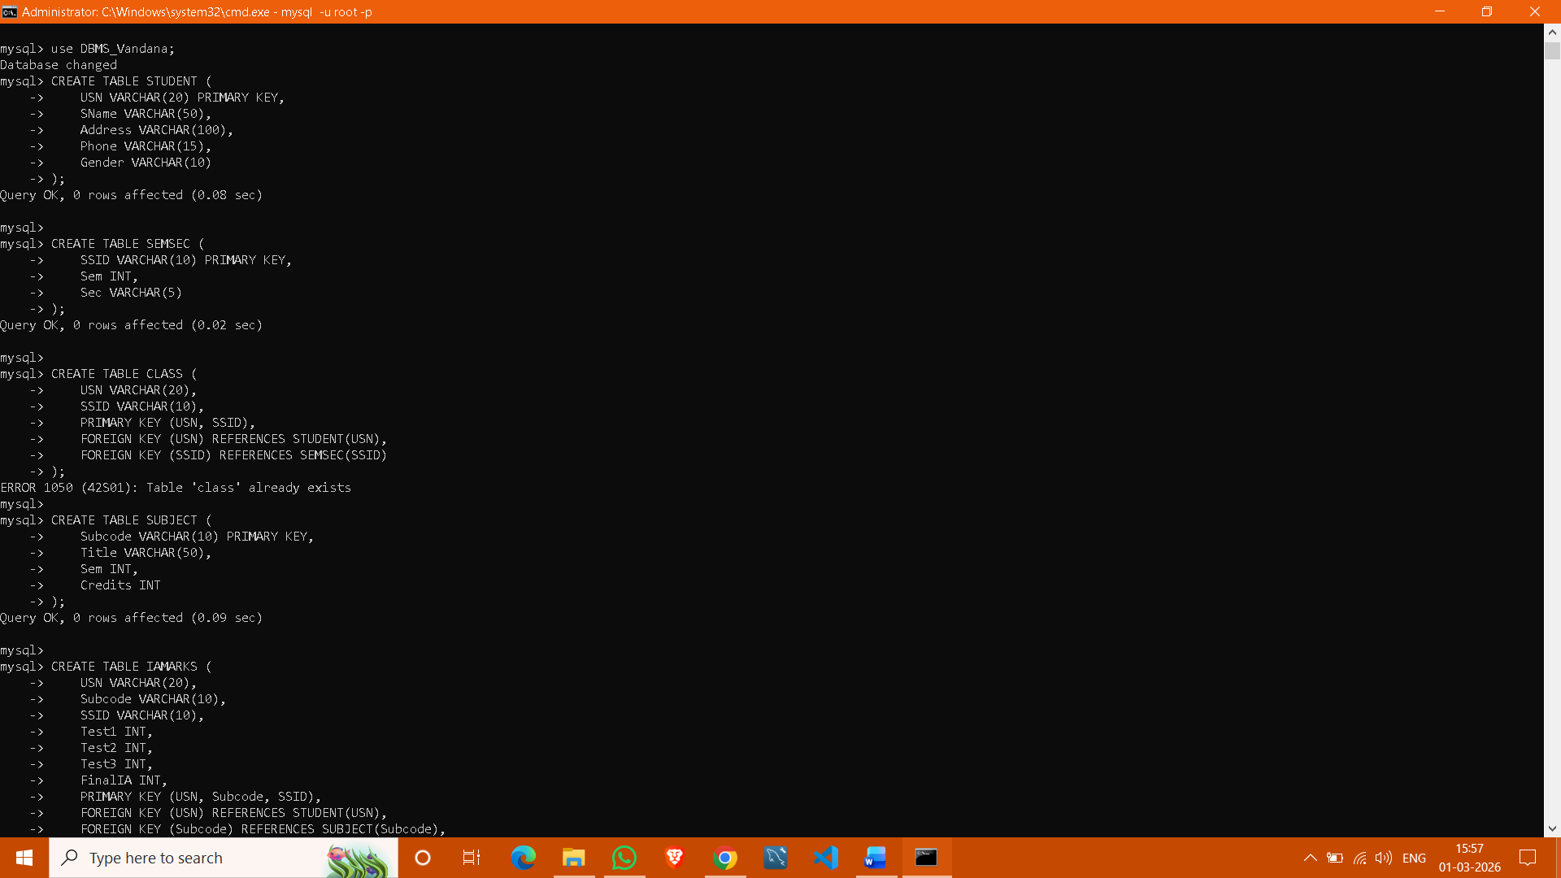

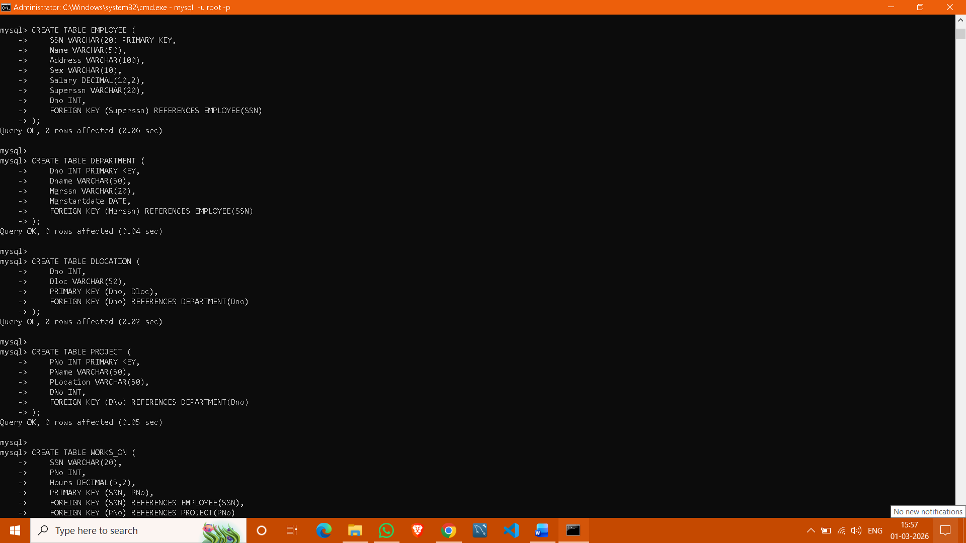

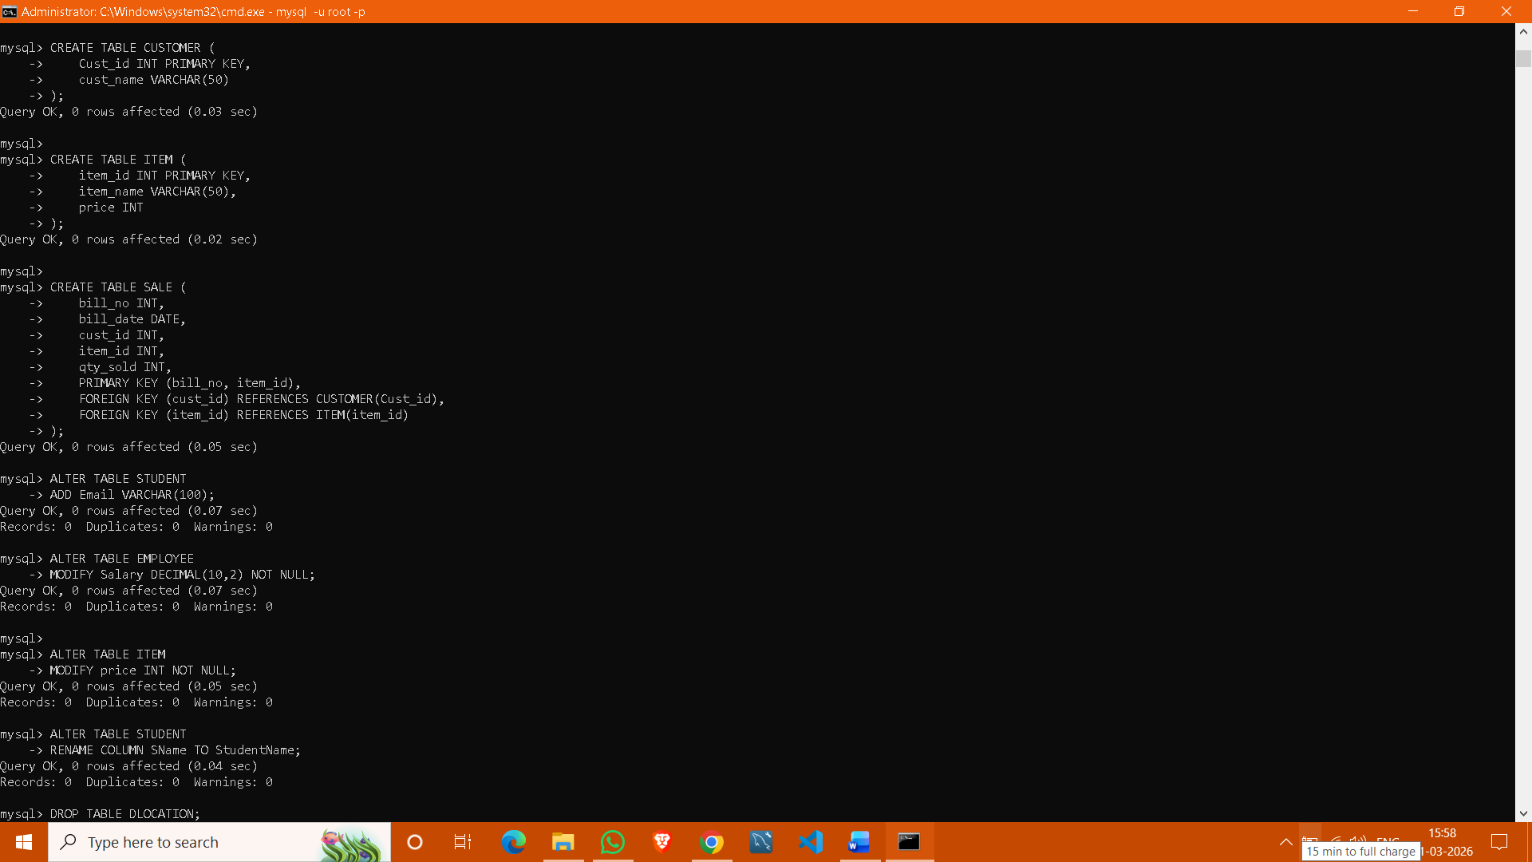
DML Questions (Data Manipulation Language):

- Insert at least 10 tuples into CUSTOMER, ITEM, and SALE relations.
- List all bills of the current date with customer names and item names.
- Display total bill amount using quantity and price.
- List customers who purchased products priced above 200.
- Count the number of products purchased by each customer.
- List products purchased by customer having Cust_id = 5.
- Create a VIEW showing bill_no, bill_date, cust_id, item_id, price, qty,sold, amount.
Create a VIEW showing daily sales date-wise for the last one week.

